The Foundry @Time Inc. | Visit California

Blog: Brandi

Northern California

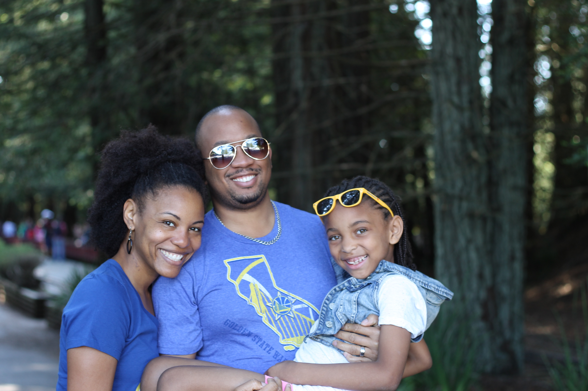

Thanks to my father’s military status, I was very fortunate to be able to travel the world when I was growing up. No place I’ve been, however, compares to Northern California. Friendly folks who feel like neighbors, the influence of many diverse cultures, and a chill vibe make it easy for anyone to feel comfortable here. Five years ago, when I first visited the region, I dreamed that I could one day call it home. Three years ago, that dream became a reality, and I’m so proud to raise my daughter here and call Oakland, California my forever home!

There’s nothing to not love about where I live. From the awesome weather year round to the abundance of fun family activities, it’s no wonder that my friends and family all start concocting plans to relocate after vacationing here. It doesn’t hurt that I know all of the best places to take them to make them fall in love with our neck of the woods (or beach, or city...more on that later!). Northern California, the Bay Area in particular, is the ultimate family playground. Whether you have one child like I do, or a whole group of them, there’s plenty to keep your entire family happy.

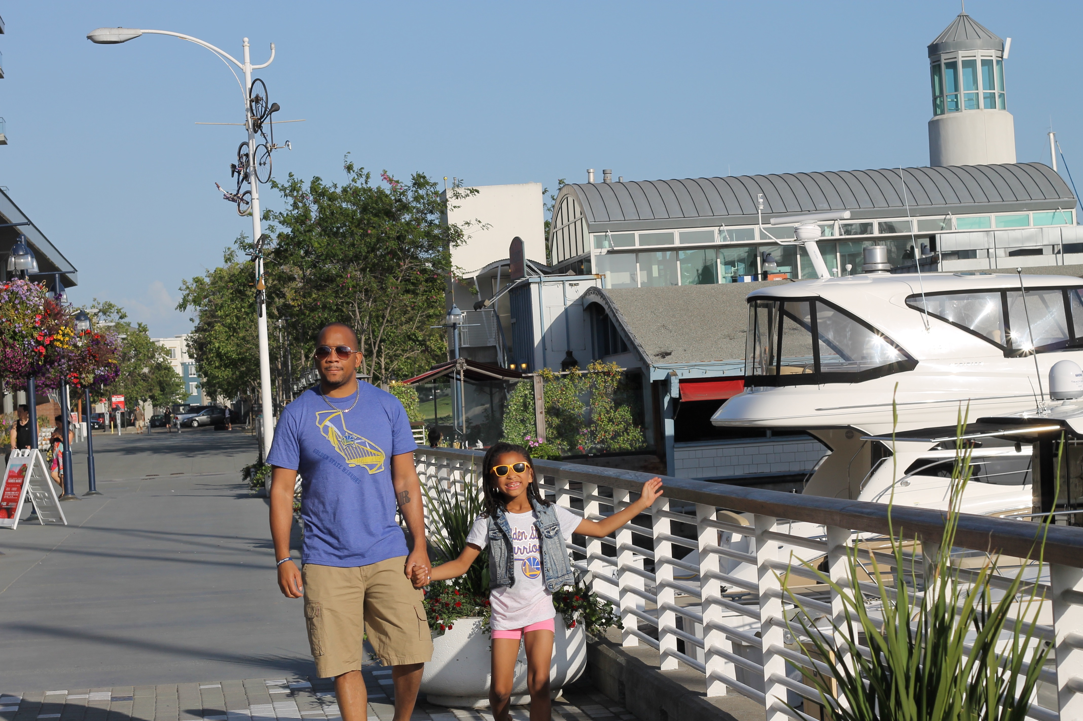

Because there’s so much to do here, it’s easy to be overwhelmed by the choices. Don’t worry, Mama Knows It All has you covered! If you’re visiting the area for the first time, or you live here but want to get out and explore more, here’s a three-day itinerary that will help you cover the most ground...and have the most fun in Northern California!

My best piece of advice, for your entire trip, is to start early. There are so many hidden treasures in Northern California that it’s likely you’ll discover something that will get you off schedule, so our family has learned to stay flexible and get out as soon as we can after the sun rises. Trust me, you’ll appreciate this tip when you find a cool park that you want to hang out in for an hour or so!

**Day 1 - Oakland and Berkeley**

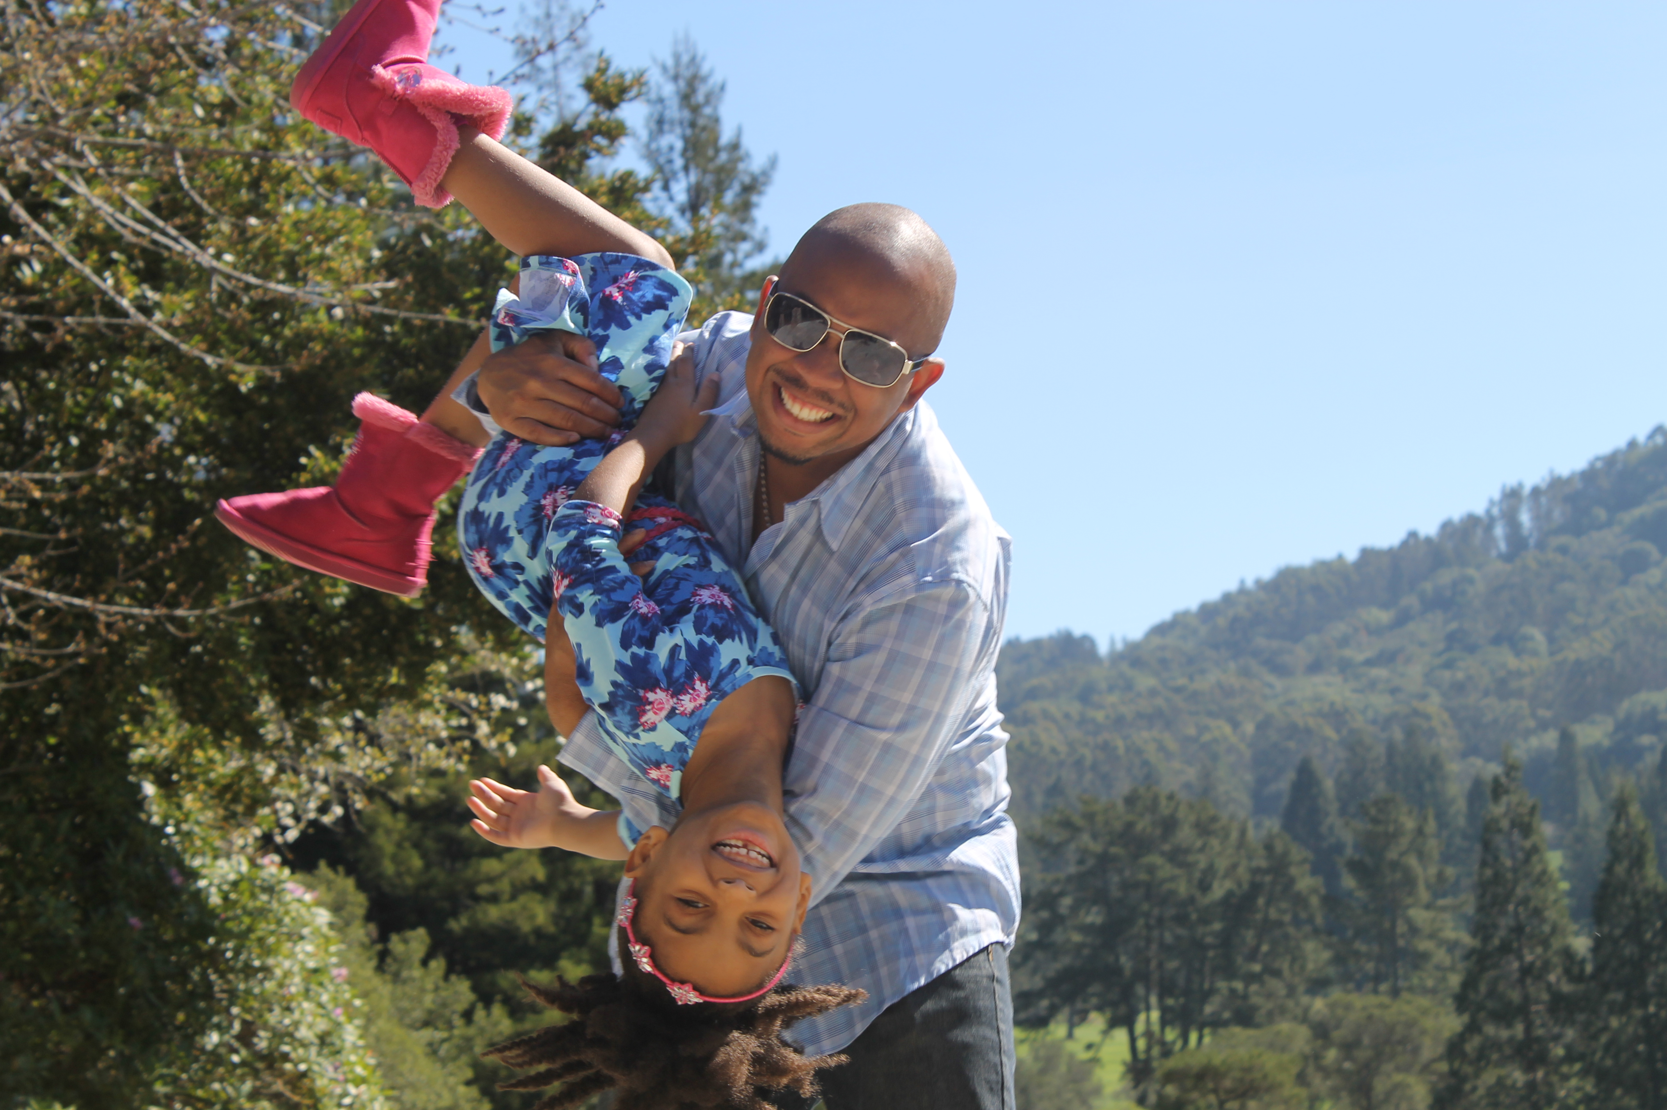

I know, I know, everyone loves San Francisco. I do, too! You don’t have to rush into the city during your Northern California visit, though. In fact, it’s a good idea to pace yourself, especially if you’re traveling with children. Starting in San Francisco’s neighboring cities, Oakland and Berkeley, is a great way to start your vacation, and set the tone for the trip. Besides, they’re both extraordinarily family-friendly, with plenty to do and lots to keep the kiddos occupied and engaged.

**Children’s Fairyland**

Our family first fell in love with Children’s Fairyland on our first visit to Oakland. Super-duper kid-friendly, this fairytale-themed amusement park will be loved by children of all ages. Ride the Jolly Trolly train, sit in on a puppet show, or meet new animal friends in the menagerie. You can experience the entire park in just a couple of hours, which leaves plenty of time for you to keep exploring.



**Jack London Square**

After Children’s Fairyland, take a short ride to Jack London Square for lunch, and you’re sure to find something interesting going on, too. It might be the day of the Farmers Market, there could be a dance party happening, or maybe your favorite movie is playing on the big screen. We never know what to expect when we go to Jack London Square! The one thing we can be sure of, though, is a great assortment of delicious restaurants!

**Tilden Park**

Once you finish lunch, it’s time to head over to Tilden Park in Berkeley. There’s a farm with a petting zoo, a carousel, botanic garden, and a steam train! Make sure you bring a blanket, because the acres of lush grass are perfect for a quick nap to refuel after you experience all the park has to offer.

**Shorebird Park Nature Center and Adventure Playground**

When you get your second wind, take the family to Shorebird Park Nature Center and Adventure Playground for another interesting experience.  A quintessentially Berkeley attraction, this park is unlike any playground you’ve ever been to. There's a zip line that kids and adults can ride on, and opportunities for children to build things with real hammers and nails, and to use paint to decorate their very own fort. The Shorebird Park Nature Center and Adventure Playground might be your kiddo’s favorite part of the entire day!



**Day 2 - San Francisco**

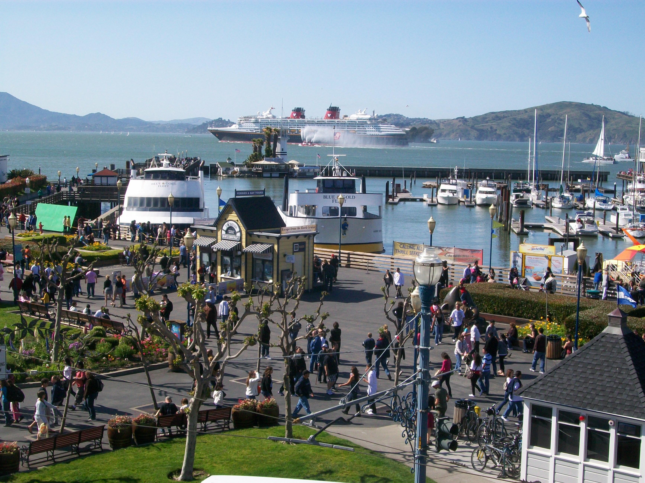

The starlet of Northern California is obviously San Francisco. It’s one of the most famous cities in the world. If you’re in the region, you absolutely cannot miss it. If you start in Oakland, you can take the ferry from Jack London Square over to Fisherman’s Wharf for an exciting beginning to a day in the city. Even if you don't take the ferry, BART is a super affordable way to get into San Francisco, or you can leave the car at one of the many parking garages that are available.

**Fisherman’s Wharf**

No matter what your plans are, Fisherman’s Wharf has to be on your agenda. There’s so much to do there! You can see some ships, get a glimpse of Alcatraz, and watch the sea lions sunbathe or play. I have to warn you, though: It might be hard to drag the family to the next attraction after they see the sea lions! They’re just so darn interesting to watch!

**Chinatown**

San Francisco’s Chinatown neighborhood is one of my favorite places in the city. It’s so full of color, and there are tons of little surprises in every single shop you go into. The best part of Chinatown is that you get to experience the slopes and hills that San Francisco is known for!

**Golden Gate Bridge**

Since it’s one of the most iconic bridges in the country, you have to go over the Golden Gate bridge if you’re in Northern California. Every few weeks I try to sweet-talk my husband into driving me over the bridge because I absolutely love the views! Not only will your kids be impressed by the sheer size and beauty of the bridge, but it takes you to one of the most lovely little cities in our area.

**Sausalito**

After you drive over the Golden Gate Bridge, make your way to the Bay Area Discovery Museum. With its focus on imagination, creativity, and STEM activities, even the adults in the family will be engaged at the museum. There are often special events going on, so make sure you check the museum calendar before you go. After you leave, check out some of the shops in downtown Sausalito, and sit down for lunch at one of the many family-friendly restaurants in the area.

**Treasure Island**

To end your day, head over to Treasure Island, right off the end of the Bay Bridge, to watch the sunset. You won’t find a better view of San Francisco anywhere else. It’ll be the perfect close to a fun-filled day, and a memory that you’ll never, ever forget!

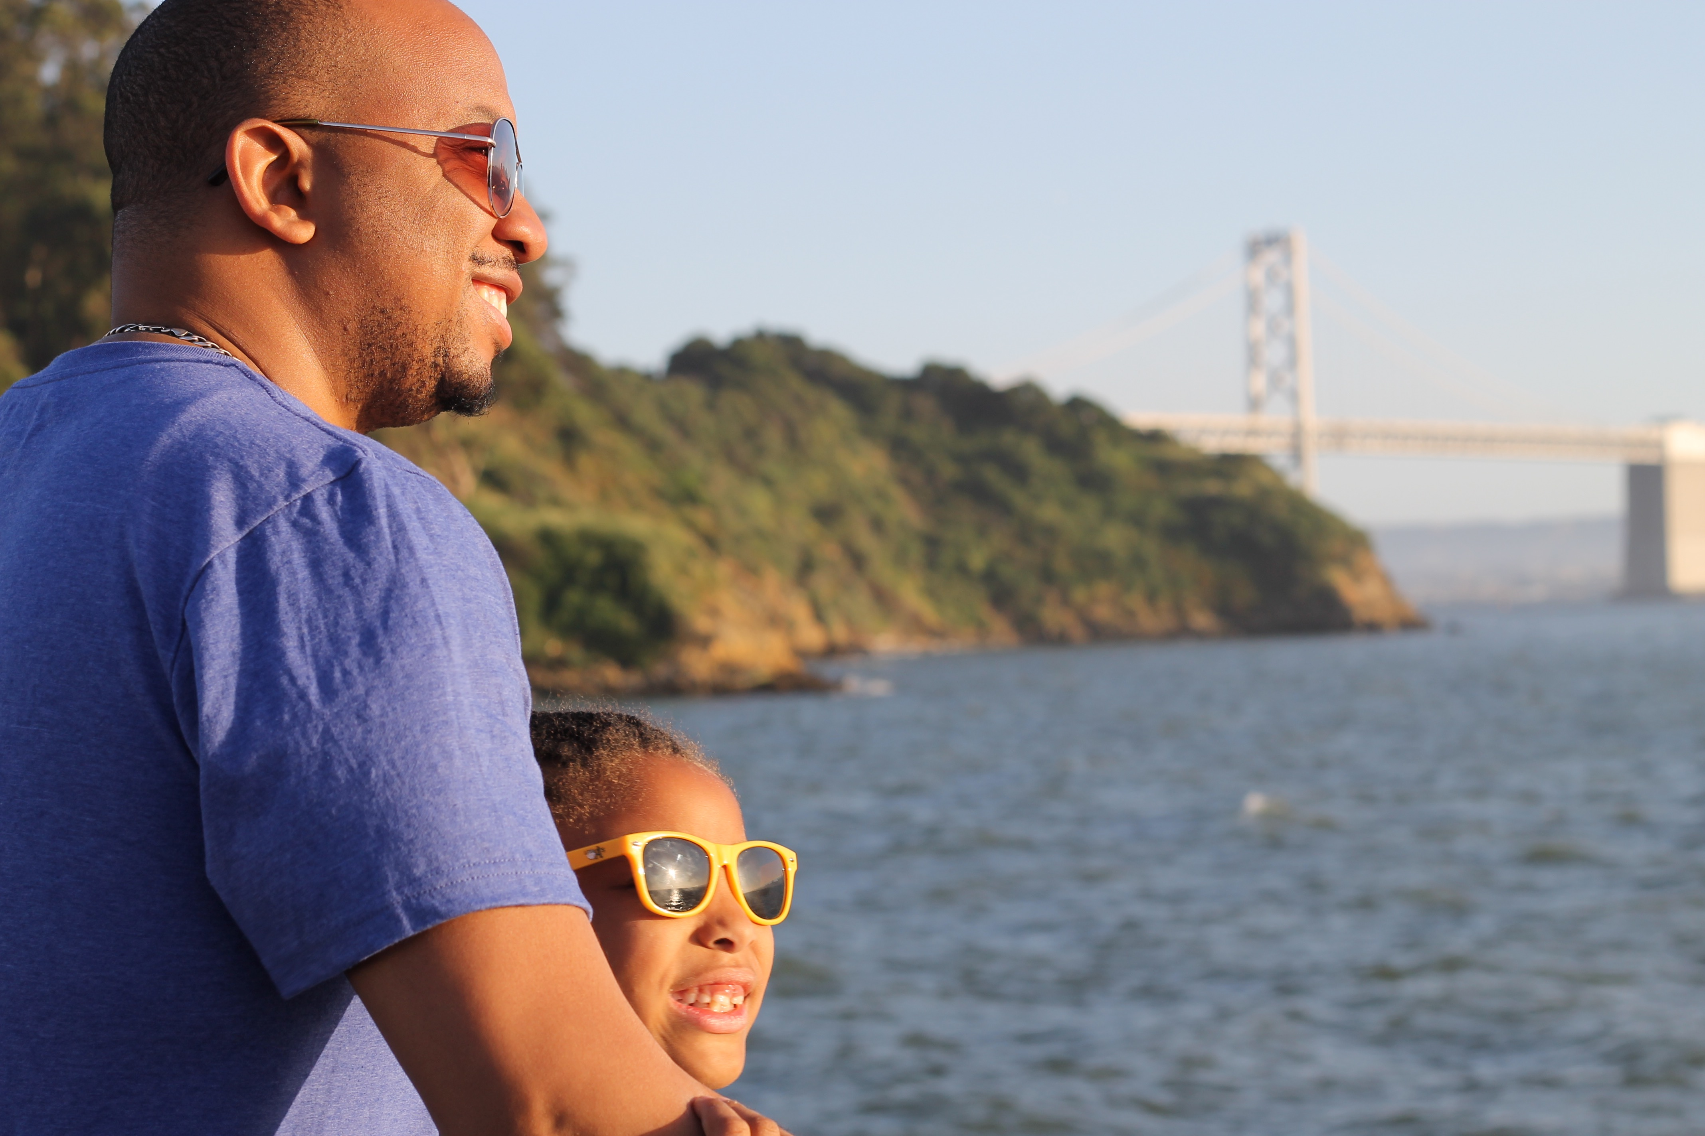

**Day 3 - Northern California Wildcard**

For your third day in our lovely region, I have several recommendations for day trips. Don’t forget my earlier advice to stay flexible and be open to the adventure you might find.

**Option #1: Yosemite National Park**

**Yosemite National Park**

If you are coming to Northern California and you only have a few days, you MUST go to Yosemite National Park. It’s about a 2.5-hour drive from Oakland, so if you start early in the morning, you'll have plenty of time to explore. One of the greatest parks in our country, Yosemite is absolutely breathtaking. When you and your family experience the amazing valley and beautiful waterfalls, you’ll be reminded of how beautiful our country truly is.

**Option #2: Santa Cruz**

**Santa Cruz Beach Boardwalk**

When I lived on the East Coast, one of my favorite things to do with my daughter was take a bus to the shore and hang out at the beach. Our version of that is the Santa Cruz Beach Boardwalk with its classic amusements, rides, and attractions. There’s a Ferris wheel, games, miniature golf, and great beach-themed foods. Your family will have the best time at the Santa Cruz Boardwalk!

**Henry Cowell Redwoods State Park**

If you want to experience the majesty of the beautiful redwood trees, Henry Cowell Redwoods State Park in Felton is the place to be. Make sure to bring your camera to take tons of pictures of the family in this amazingly beautiful setting!

**Natural Bridges State Beach**

Before you leave the Santa Cruz area, make a stop at Natural Bridges State Beach to see the sun set. My husband and I had engagement photos taken here, and I can *guarantee* you one of the most gorgeous sunsets you’ll ever see in your life.

**Option #3: San Jose**

**San Jose**

You may know San Jose as the tech center of Northern California, but there’s plenty for families to do there, too! Just about an hour away from Oakland, San Jose makes a fun and easy day trip. Start your morning at Happy Hollow Park and Zoo for a close up look at some really sweet animals. After that, head over to the Children’s Discovery Museum for lunch and to play. You and your kiddos will love the gardens, imaginative exhibits, and opportunities to engage with science.

Now do you see why it was so easy for me to fall in love with Northern California? It’s the very best of everything our great country has to offer, and there’s no place I’d rather live, love, and have fun!